3
Stambourne Parish Council

Notice of conclusion of audit
Annual Governance & Accountability Return for the year ended 31 March 2026
Sections 20(2) and 25 of the Local Audit and Accountability Act 2014
Section 16 of the Accounts and Audit Regulations 2015 (Sl 2015/234)
The audit of accounts for Stambourne Parish Council for the year ended 31 March 2026 has been completed and the accounts have been published.  - The Annual Governance & Accountability Return including the auditor's certificate and opinion is available for inspection and copying by any local government elector of the area of Stambourne Parish Council on application to:  (a) 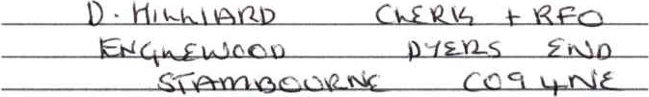  (b)  - Copies will be provided to any local government elector of the area on payment of for each copy of the Annual Governance & Accountability Return.  Announcement made by: (d)  Date of announcement: (e) 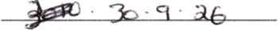 | Notes  This notice and Sections 1 , 2 & 3 of the AGAR must be published by 30 September. This must include publication on the smaller authority's website. The smaller authority must decide how long to publish the Notice for; the AGAR and external auditor report must be publicly available tor 5 years.  - Insert the name. position and address of the person to whom local government electors should apply to inspect the AGAR  - Insert the hours during which inspection rights may be exercised  - Insert a reasonable sum for copying costs  - Insert the name and position of person placing the notice  - Insert the date of placing of the notice
www.pkf-l.com

