Annual Governance Statement 2025/26
We acknowledge as the members of:
our responsibility for ensuring that there is a sound system of intemal control, including arrangements for the preparation of the Accounting Statements. We confirm, to the best of our knowledge and belief, with respect to the Accounting Statements for the year ended 31 March 2026, that:
 | Agreed
 | Yes
I. We have put in place arrangements for effective financial management during the year. and for the preparation of the accounting statements. | J/ |  | prepared its accounting statements in accordance with the Accounts and Audit Regulations.
2. We maintained an adequate system of internal control including measures designed to prevent and detect fraud and corruption and reviewed its effectiveness. |  |  | made proper arrangements and accepted responsibility for safeguarding the public money and resources in its charge.
3. We have assured ourselves that there are no matters of actual or potential non-compliance with laws, regulations and Proper Practices that could have a significant financial effect on the ability of this authority to conduct its business or manage its finances. |  |  | has only done what it has the legal power to do and has complied with Proper Practices in doing so.
4. We provided proper opportunity during the year for the exercise of electorS rights in accordance with the requirements of the Accounts and Audit Regulations. | V/ |  | during the year gave all persons interested the opportumty to inspect and ask questions about this authority's accounts.
5. We carned out an assessment of the risks facing this authority and took appropriate steps to manage those risks. including the introduction of internal controls and/or external insurance cover where required. |  |  | considered and documented the financial and other risks it faces and dealt with them property.
6. We maintained throughout the year an adequate and effective system of internal audit of the accounting records and control systems. |  |  | arranged for a competent person, independent of the financial controls and procedures. to give an objective view on whether intemal controls meet the needs of this smaller authority.
7. We took appropriate action on all matters raised in reports from intemal and extemal audit. | v/ |  | responded to matters brought to its attention by intemal and external audit.
8. We considered whether any litigation. liabilities or commitments. events or transactions. occurring either during or after the year-end, have a financial impact on this authority and, where appropriate. have included them in the accounting statements. |  |  | disclosed eveMhing it should have about its business activity during the year including events taking place after the year end if relevant,
9. (For local councils only) Trust funds including charitable. In our capacity as the sole managing trustee we discharged our accountability responsibilities for the fund(s)/assets, including financial reporting and, if required, independent examination or audit. | 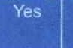 No |  |  | has met all of Its responsibilities where. as a body corporate. it is a sole managing trustee of a local trust or trusts.
10. We have put in place arrangements ror the effective IT and data management in accordance with proper practices during the year under review. |  |  | has made suitable arrangements for its IT and data management and has complied with proper practices in doing so.
*Please provide explanations to the external auditor on a separate sheet for each 'No' response and describe how the authority will address the weaknesses identified. These sheets must be published with the Annual Governance Statement.
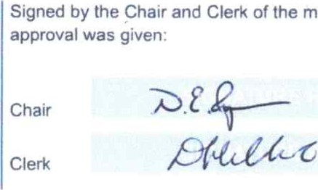
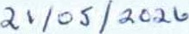
This Annual Govemance Statement was approved at a meeting of the authority on:
meeting
where
and recorded as minute reference:
a-L/SH

Annual 3 4
Local
Accounting Statements 2025/26 for
Cc,e L—
Notes and guidance
Please round all figures to nearest El. Do not leave any boxes blank and report EO or Nil balances. All figures must agree to underlying financial records.
 |  | 1. Balances brought forward |  | 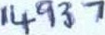 |  |  | 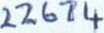 |  |  | Total balances and reserves at the beginning of the year as recorded in the financial records. Value must agree to Box 7 of previous year.
 |  | 2. (+) Precept or Rates and Levies |  |  |  |  | 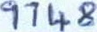 |  |  | Total amount of precept (or for IDBs rates and levies) received or receivable in the year. Exclude any grants received.
 |  | 3. (+) Total other receipts |  | 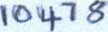 |  |  | 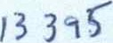 |  |  | Total income or receipts as recorded in the cashbook less the precept or rates/levies received (line 2). Include any grants received.
 |  | 4. (-) Staff costs |  | 3183 |  |  | 3133 |  |  | Total expenditure or payments made to and on behalf of all employees. Include gross salaries and wages, employers NI contributions, employers pension contributions, gratuities and severance payments.
 |  | 5. (-) Loan interest/capital repayments |  |  |  |  | O |  |  | Total expenditure or payments of capital and interest made during the year on the authority's borrowings (if any).
 |  | 6. (-) All other payments |  | 850 |  |  | 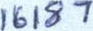 |  |  | Total expenditure or payments as recorded in the cashbook less staff costs (line 4) and loan interest/capital repayments (line 5).
 |  | 7. (=) Balances carried forward |  | 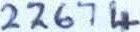 |  |  | 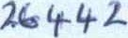 |  |  | Total balances and reserves at the end of the year. must equal (1+2+3) - (4+5+6).
 | 8. Total value of cash and short term investments |  | 12 G |  |  | 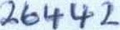 |  |  | The sum of all current and deposit bank accounts, cash holdings and short term investments held as at 31 March — To agree with bank reconciliation.
 | 9. Total fixed assets plus long term investments and assets |  | 73 153 |  |  | 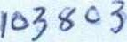 |  |  | The value of all the propeny the authority owns — it is made up of all its fixed assets and long term investments as at 31 March.
 | 10. Total borrowings |  |  |  |  |  |  |  | The outstanding capital balance as at 31 March of all loans from third parties (including PWLB).
For Local Councils Only |  |  |  |  | Yes   No
11 Do the figures in the accounting statements above exclude any trust transactions? |  |  |  |  |  |  |  | For guidance refer to the Practitioners' Guide sections 2.31 to 2.33.
I certify that for the year ended 31 March 2026 the Accounting I confirm that these Accounting Statements were
Statements in this Annual Governance and Accountability approved by this authority on this date: Retum have been prepared on either a receipts and payments or income and expenditure basis following the guidance in u /os/A0ÄG Govemance and Accountability for Smaller Authorities — a Practitioners' Guide to Proper Practices and present fairly the financial position of this authority. as recorded in minute reference: Signed by Responsible Financial Officer before being presented to the authority for approval.
Signed by Chair of the meeting where the Accounting
Statements were approved
Date

Annual 3 5
Local
External Auditor's Report and Certificate 2025/26
In respect of Stamboume Parish Council — EX0226

1 Respective responsibilities of the auditor and the authority
Our responsibility as auditors to complete a limited assurance review is set out by the National Audit Office (NAO). A limited assurance review is not a full statutory audit, it does not constitute an audit carried out in accordance with Intemational Standards on Auditing (UK & Ireland) and hence it does not provide the sarne level of assurance that such an audit would. The IJK Govemment has determined that a lower level of assurance than that provided by a full statutory audit is appropriate for those local public bodies with the lowest levels of spending.
Under a limited assurance review, the auditor is responsible for reviewing Sections 1 and 2 of the Annual Govemance and
Accountability Retum in accordance with NAO Auditor Guidance Note 02 (AGN 02) as issued by the NAO on behalf of the Comptroller and Auditor General. AGN 02 is available from the NAO website — https.•//mvw.nao.org.uk/code-auditpractice/guidance-and-information-fQrrauditors/
This authority is responsible for ensuring that its financial management is adequate and effective and that it has a sound system of intemal control. The authority prepares an Annual Govemance and Accountability Retum in accordance with Proper Practices which:
- summarises the accounting records for the year ended 31 March 2026; and
- confirms and provkies assurance on those matters that are relevant to our duties and responsibilities as extemal auditors. 2 External auditor's limited assurance opinion 2025/26
On the basis of ourreview of Sections I and 2 of the Annual Govemance and Accountability Return (AGAR), in our opinion the information in Sections I and 2 of the AGAR is in accordancewith Proper Practices and no other matters have come to our attention giving cause for concem relevant legislation and regulatory requirements have not been met.
he AGAR was not accurately completed before submission for review. The smaller authority has confirmed that it is not a sole managing rustee and hence the response to Section 2, Box Il is incorrect and should be 'yes'.
Other matters not affecting our opinion which we draw to the attention of the authority:
he smaller authority has not provided:
an adequate explanation for the variance between the prior and current year values in Box 9 of Section 2 as the authority cann confirm what the prior valuation basis of the land was.

3 External auditor certificate 2025/26
We certify that we have completed our review of Sections 1 and 2 of the Annual Govemance and Accountability Retum, and discharged our responsibilities under the Local Audit and Accountability Act 2014, for the year ended 31 March 2026.
External Auditor Name
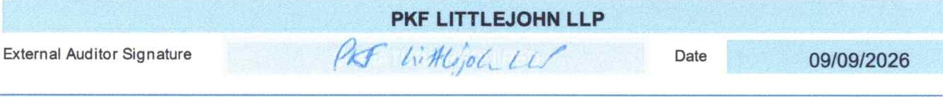
Annual 3 6
Local

